Software Design Specification (SDS)

Diet Clinic

|  |  |
| --- | --- |
| **Group Members** | |
| Tanzeel Ur Rehman | 345510 |
| M. Ali Raza Dar | 343375 |
| Raja Haider Ali | 346900 |

Version 1.0

Prepared by

# Introduction:

## System Purpose:

This is the first draft of the System Requirement Specification (SRS) for the Website named “Diet Clinic”. This document is written in accordance with rules issued by IEEE for SRS.

Diet Clinic is a private organization which sell diet plans to their customers. The organization already have social media presence on Instagram and Facebook. By owning a website, the organization can further increase its audience by providing a virtual clinic, where customers can interact with dietitian and get information about a healthy lifestyle.

By using this website, customers will be able to book their appointment with dietitian just by clicking a button and can get motivations by reading blogs about health and nutrition to improve their lifestyle. The website will also provide an online monitoring system which will show weekly, and monthly progress to customers.

## System scope:

The website will act as an online platform for the clinic. It will provide the same features available in a physical clinic. The customer will get register on the website and his whole progress will be saved in an account through which he will be able to manage his entire diet programs. Customers will be able to book virtual appointment and will be able to resolve their queries through an online chat box which will be active 24/7. Furthermore, website will have different blogs which will have real-time success stories and information about “how to life a healthy lifestyle”, to motivate the customers and enhance their knowledge.

# System Overview:

The final product is a website which is serving as an online diet clinic platform. The website is connected to the cloud server and is available in different region of the world, accessible to multiple devices including smart phones, tablets, computers etc. The website is connected to a secured database and the information of clients and professional staff is kept confidential.

# Analysis Model:

## Interface Objects:

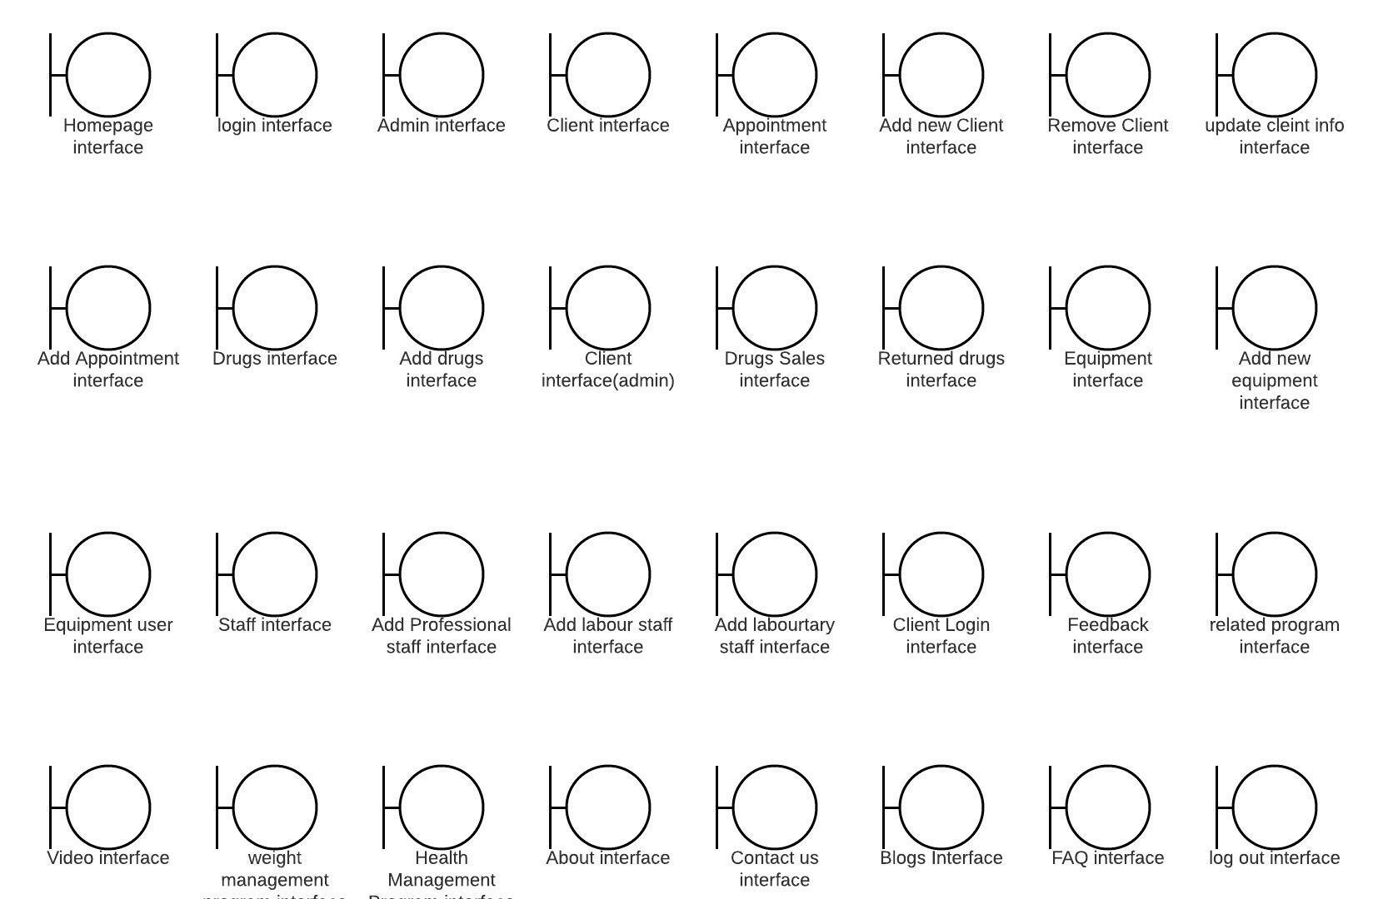

## Interface system diagram:

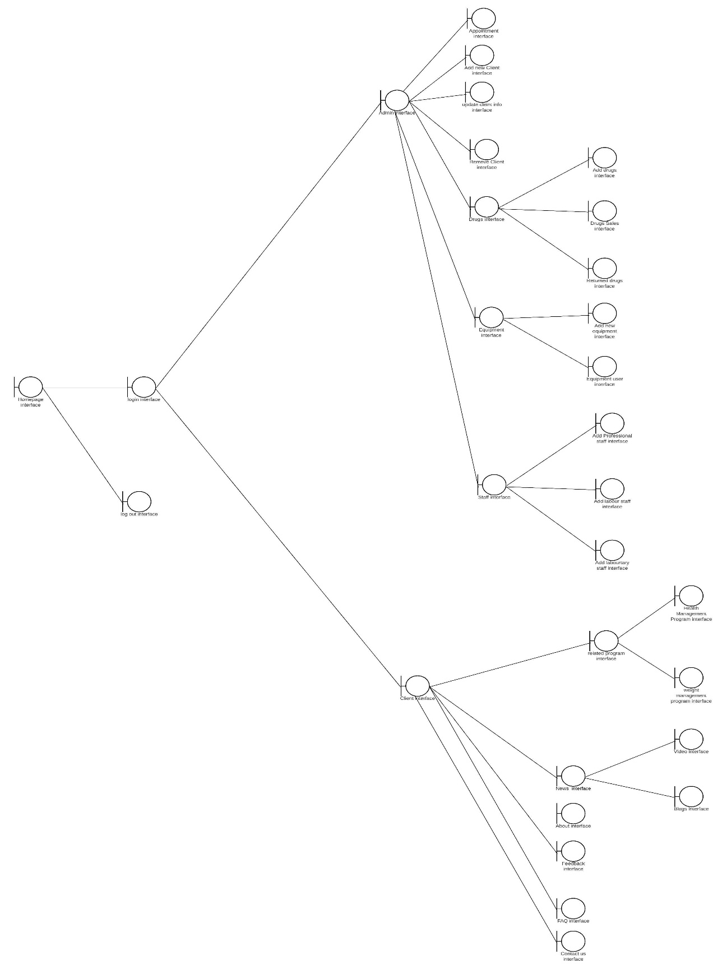

## Sub System Diagram

### Admin Interface:

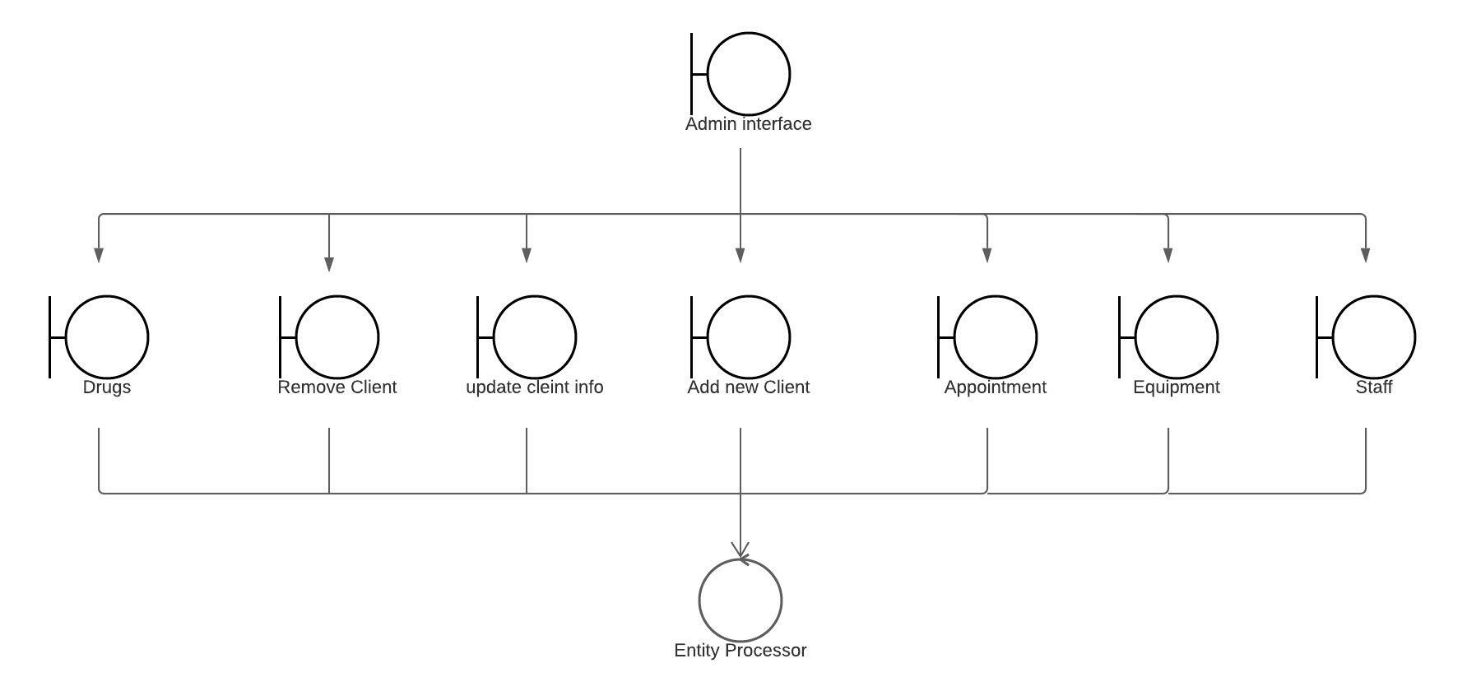

### Client Interface:

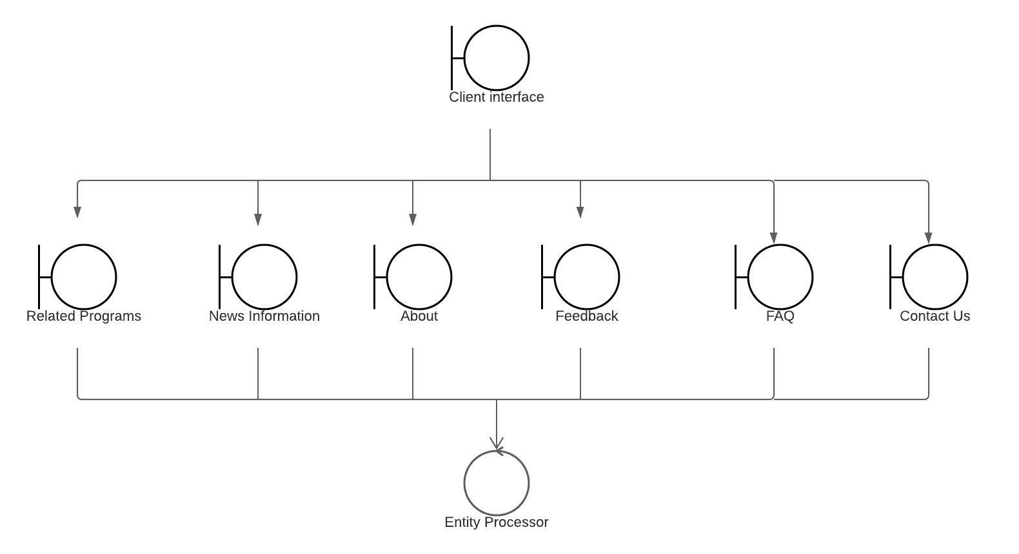

### Staff Interface:

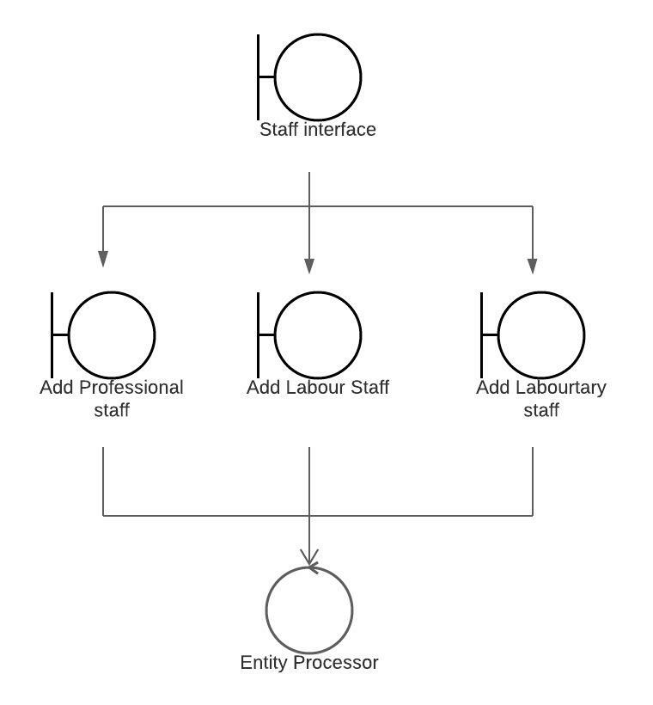

### Drug Interface:

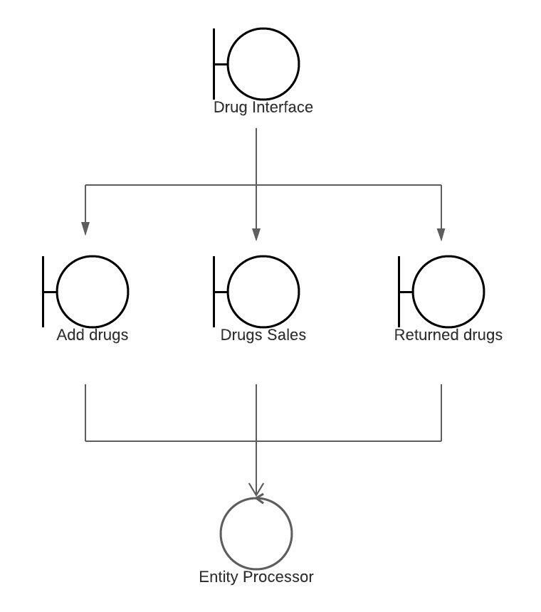

### HomePage:

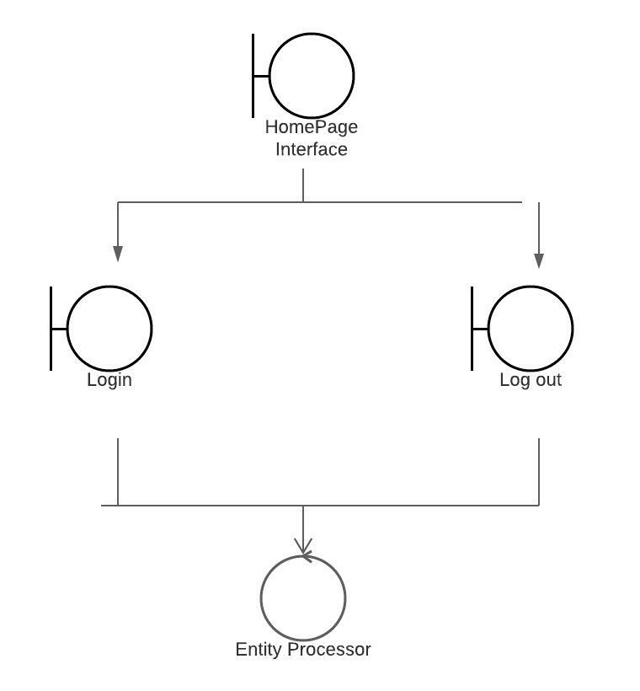

### Login:

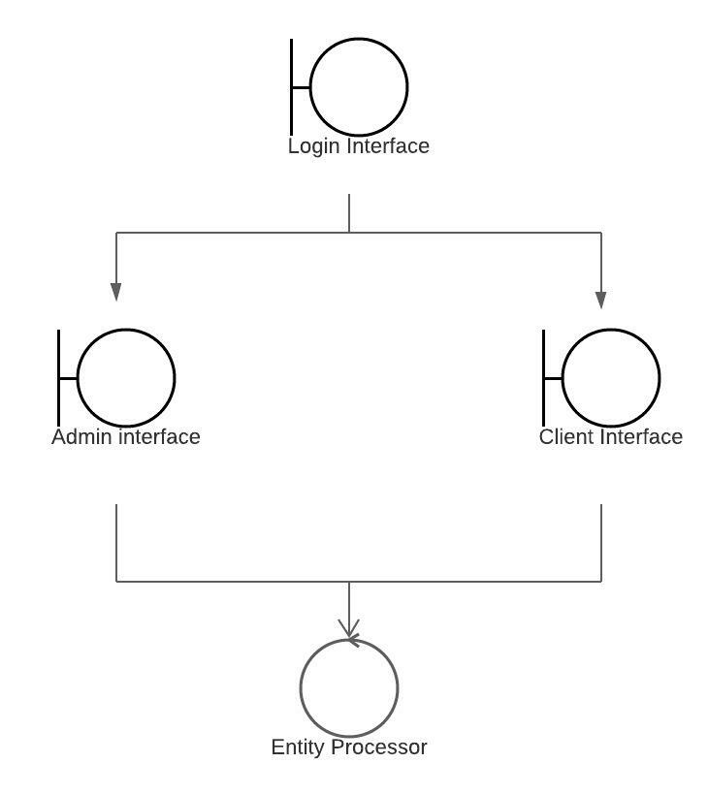

### Equipment Interface:

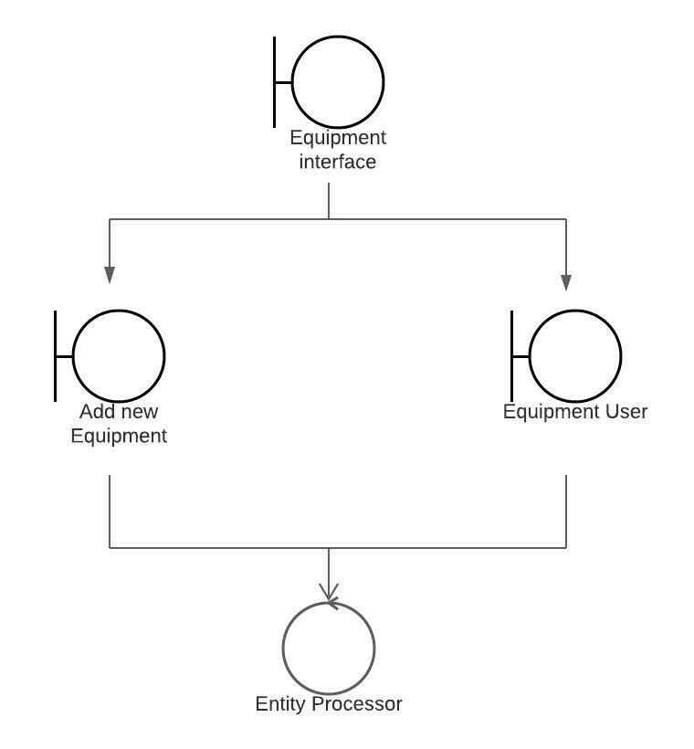

### Related Program:

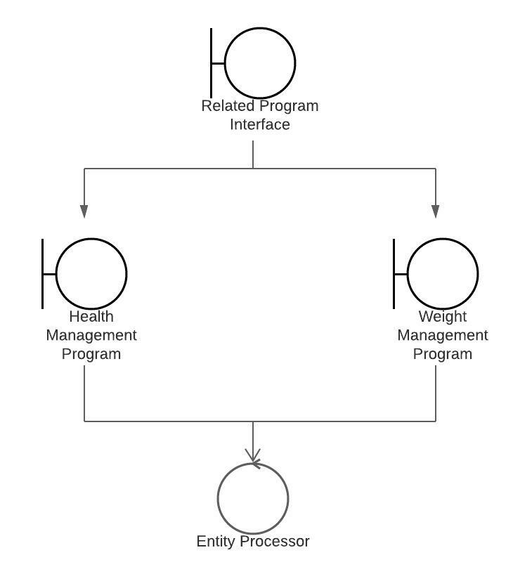

### News:

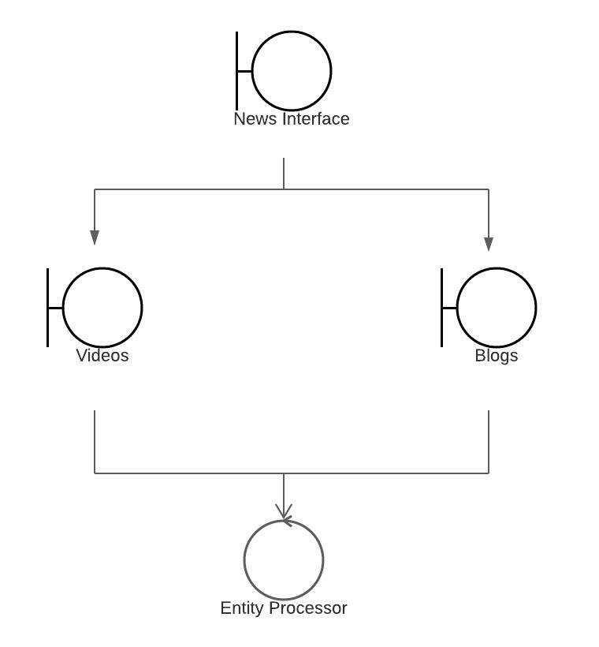

## Use Case Diagram:

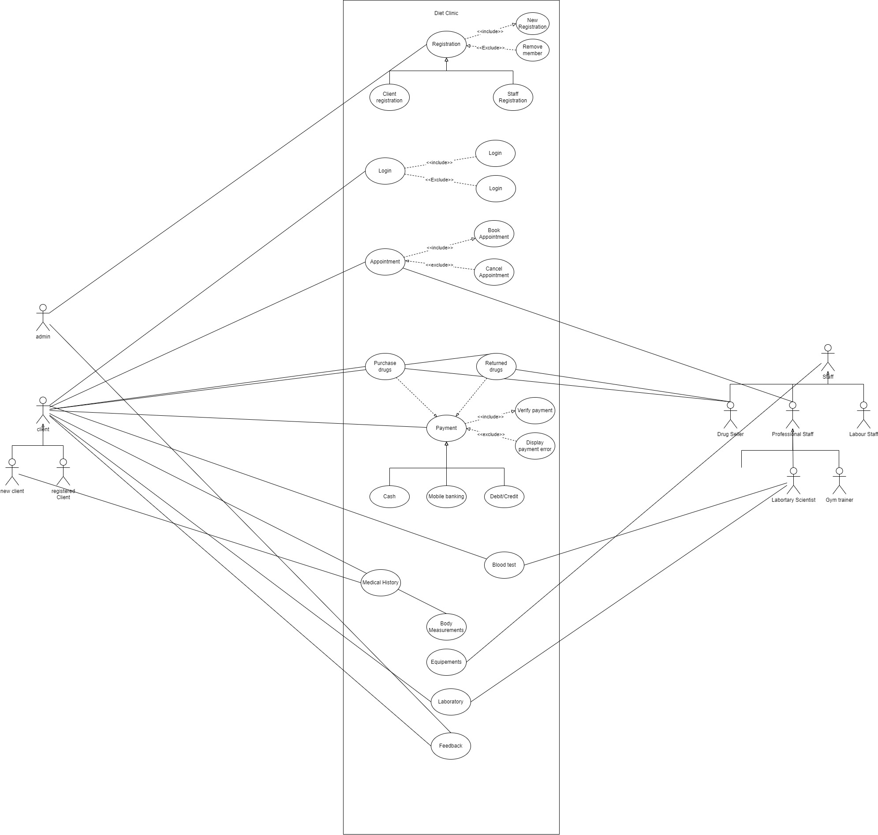

## Class Diagram:

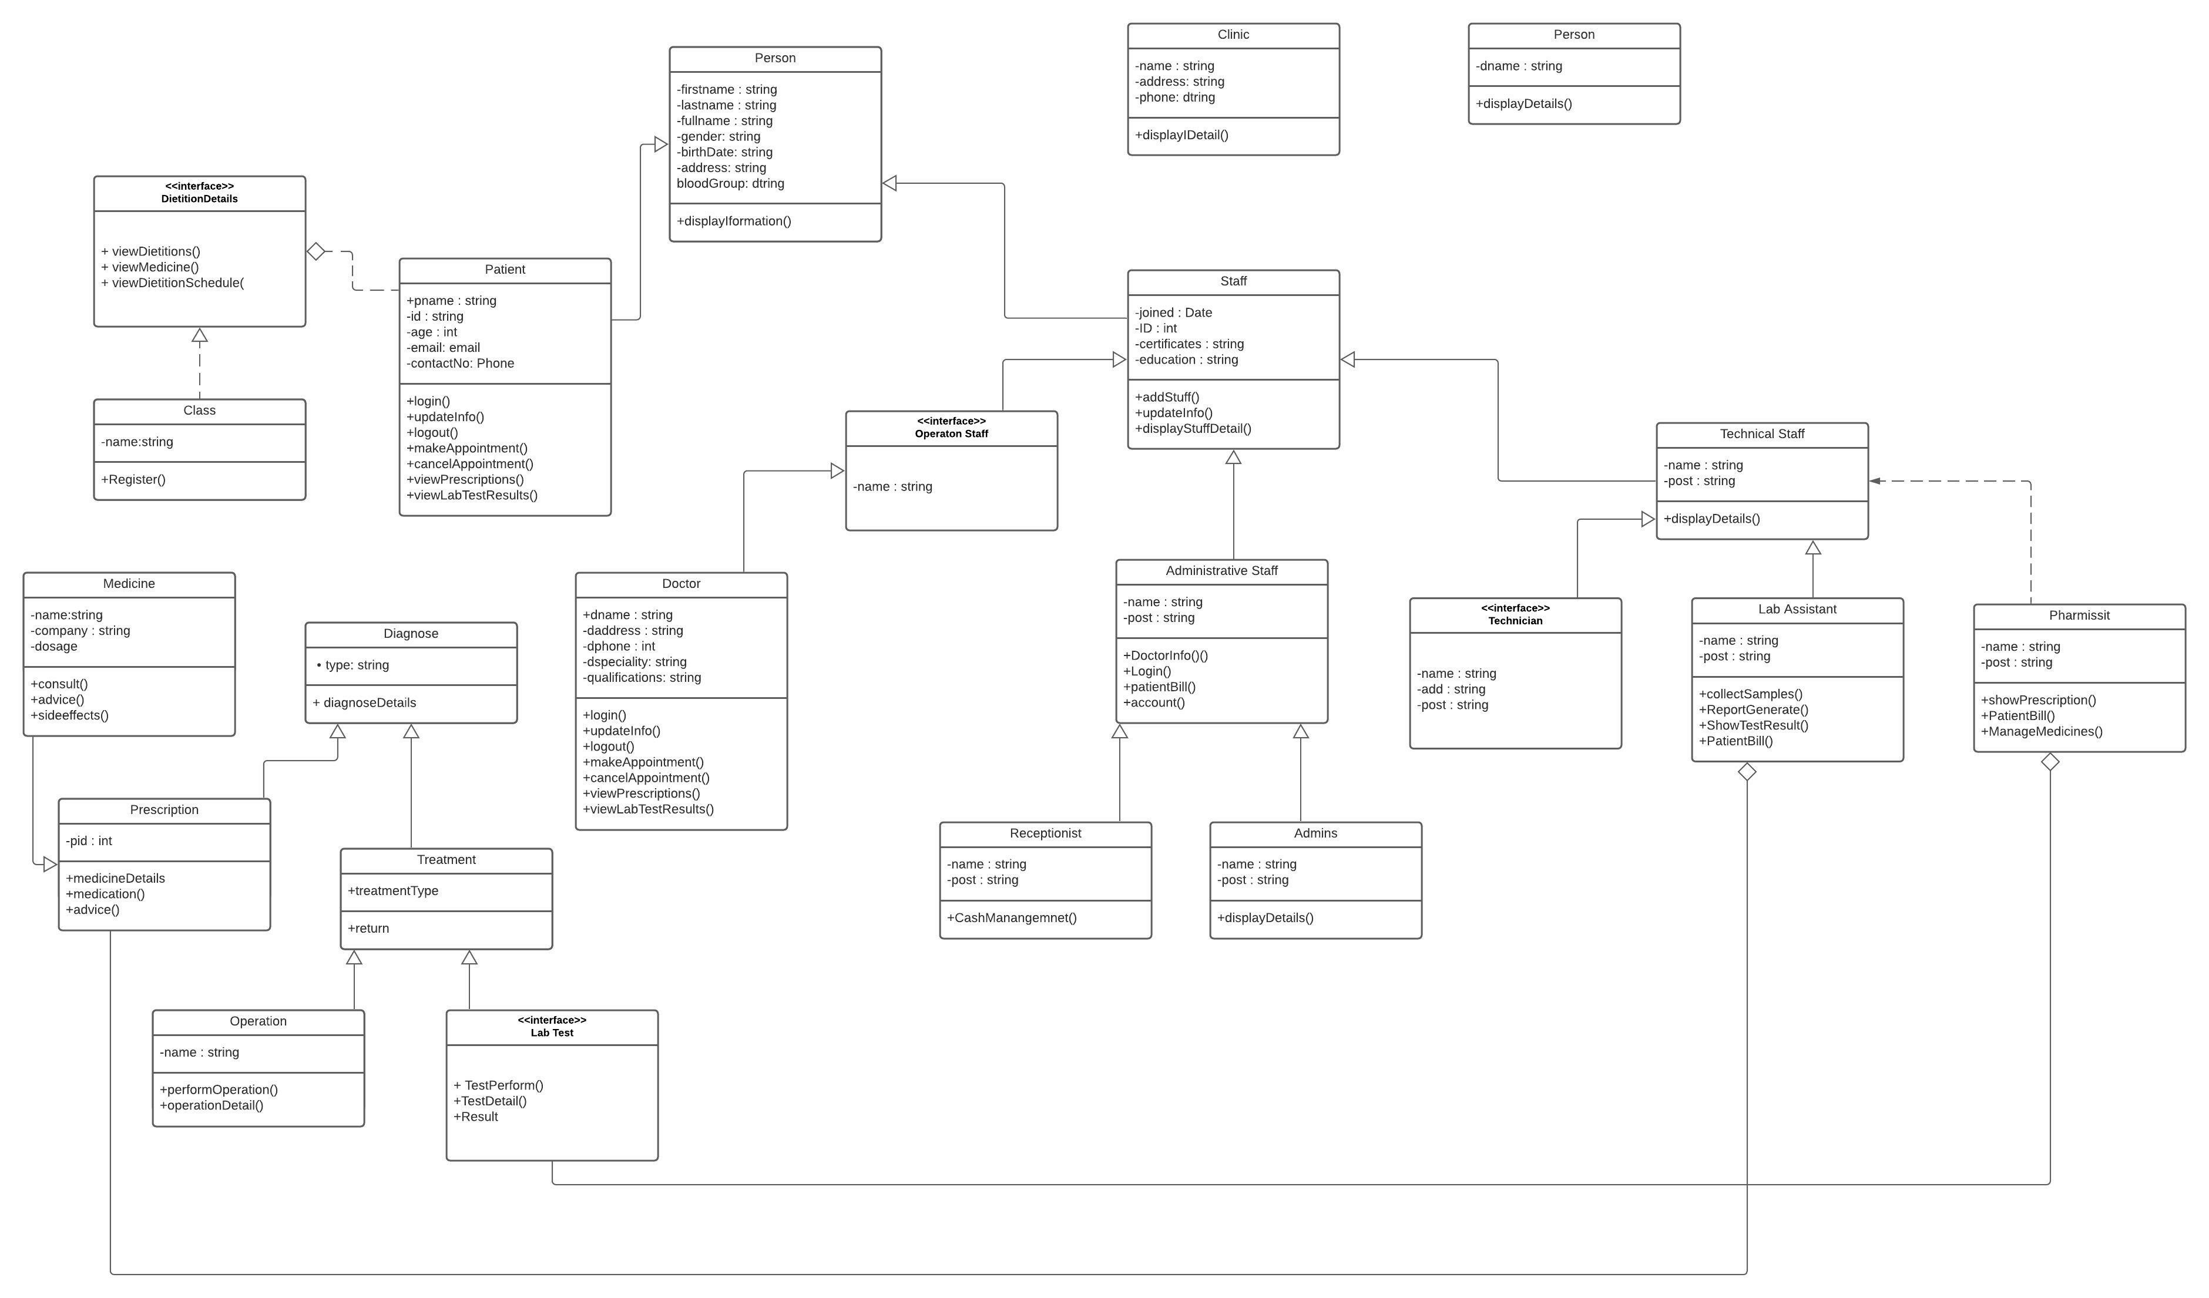

## Sequence Diagram:

### Login:

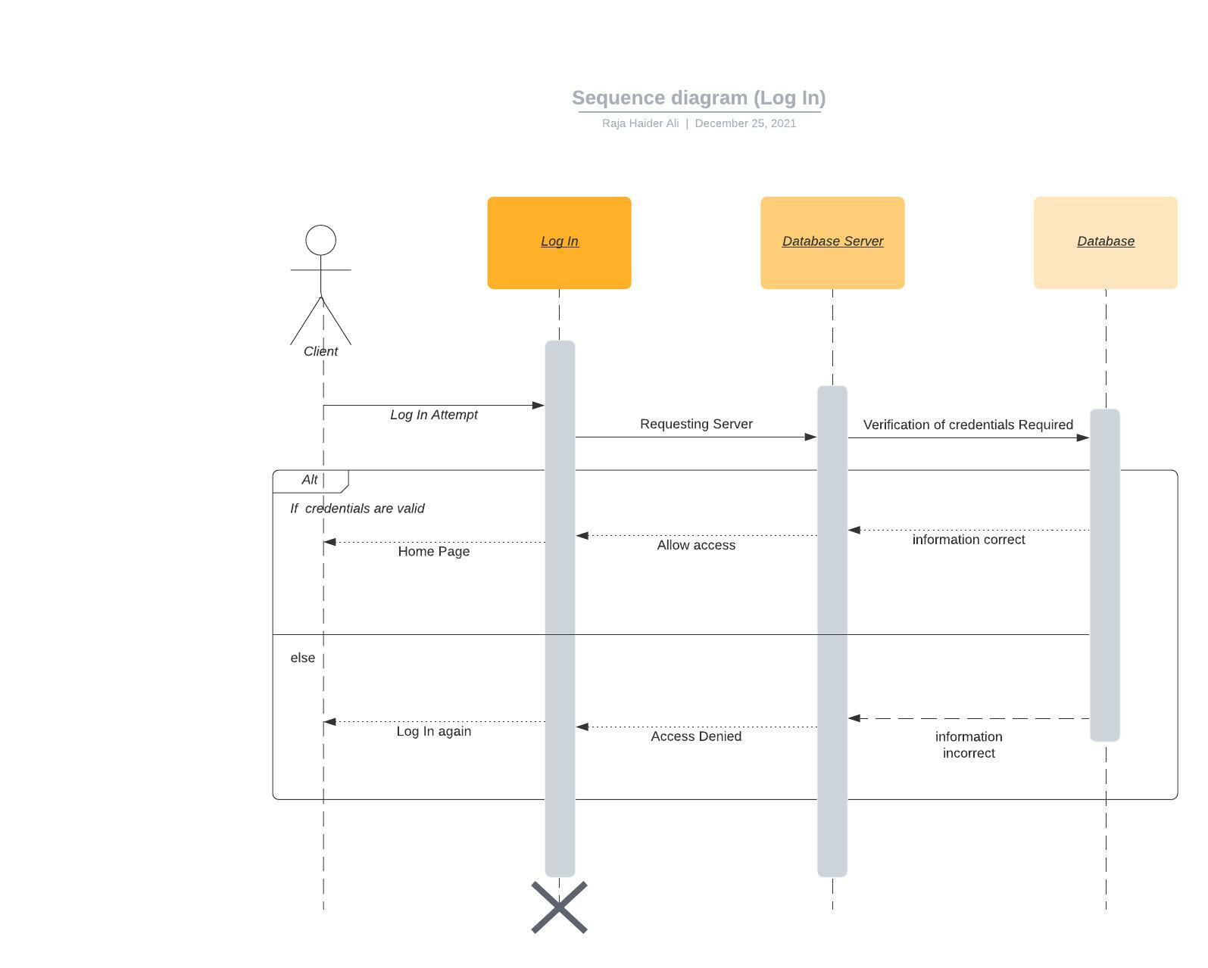

### Register Client:

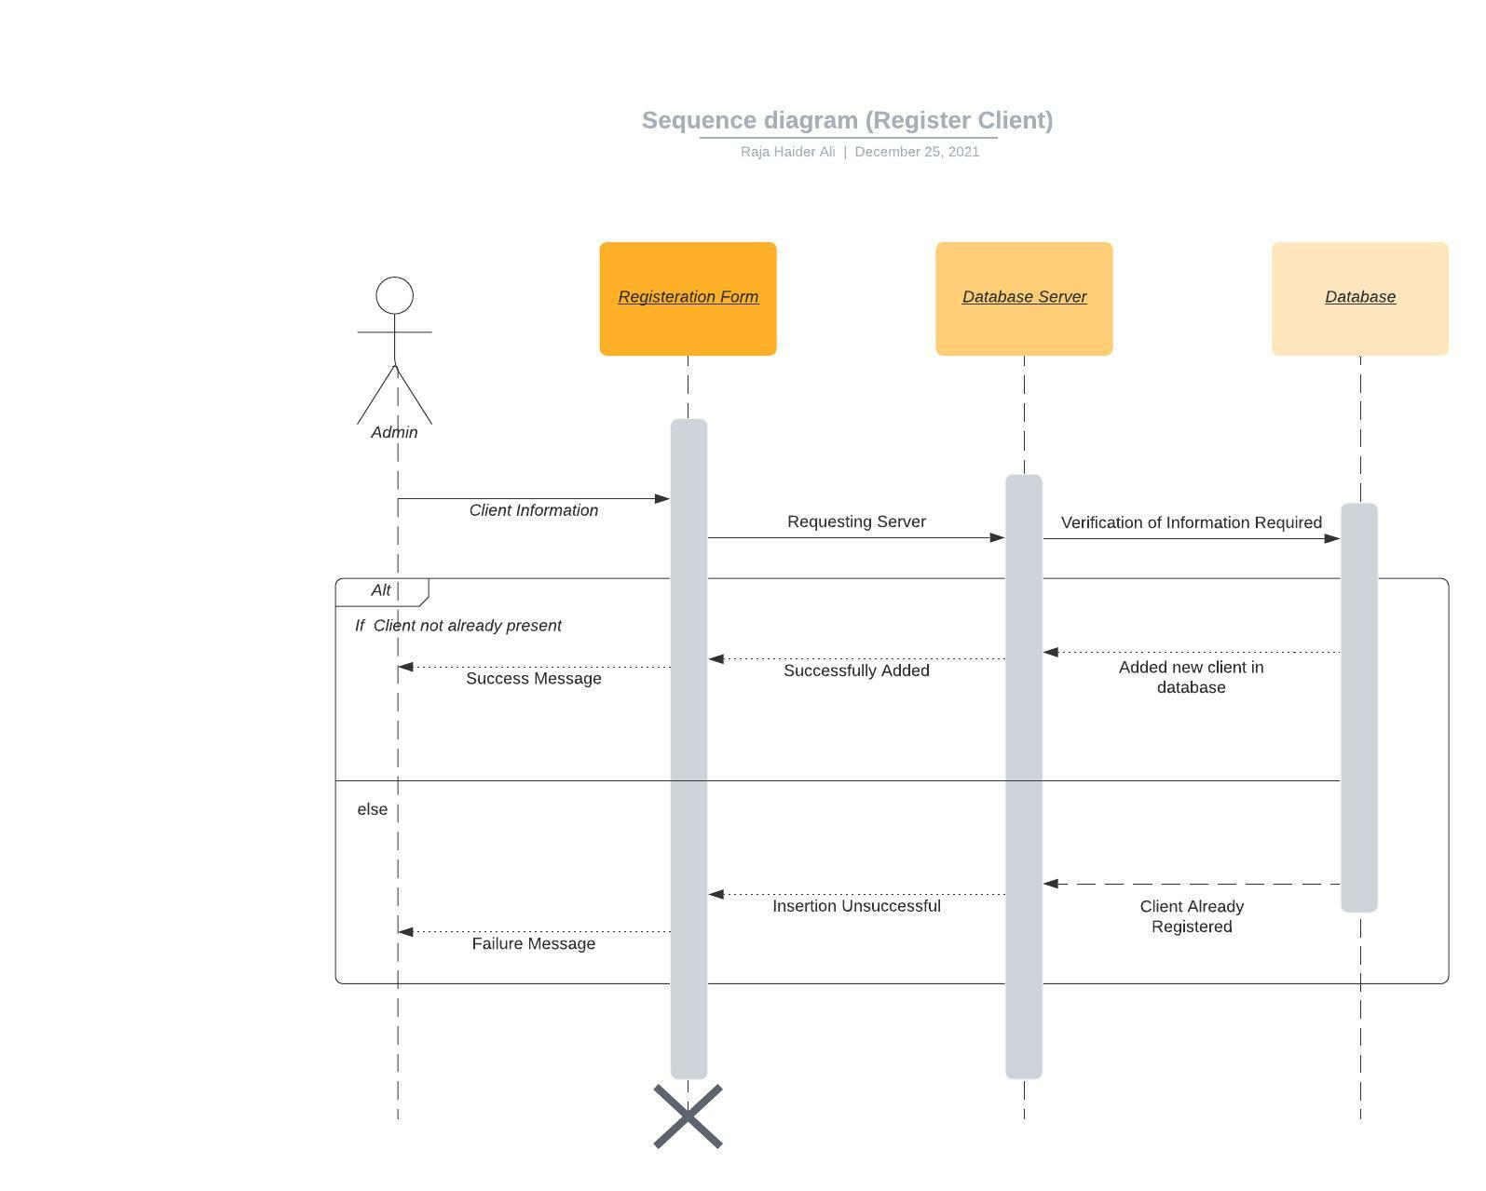

### Appointment:

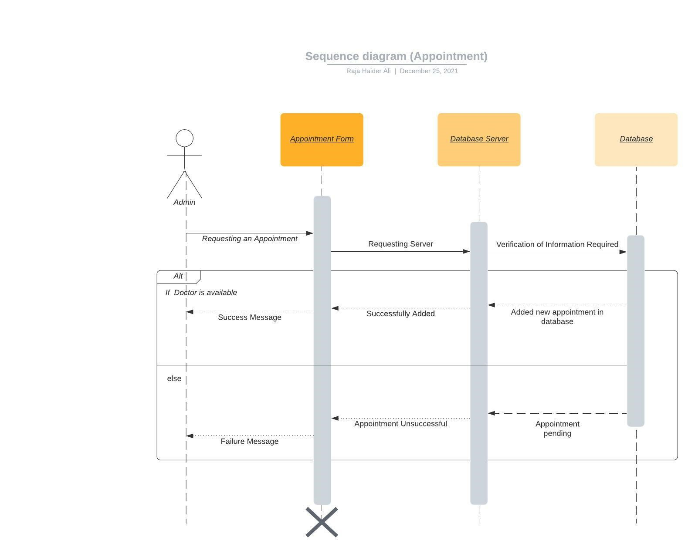

### Drugs Payment:

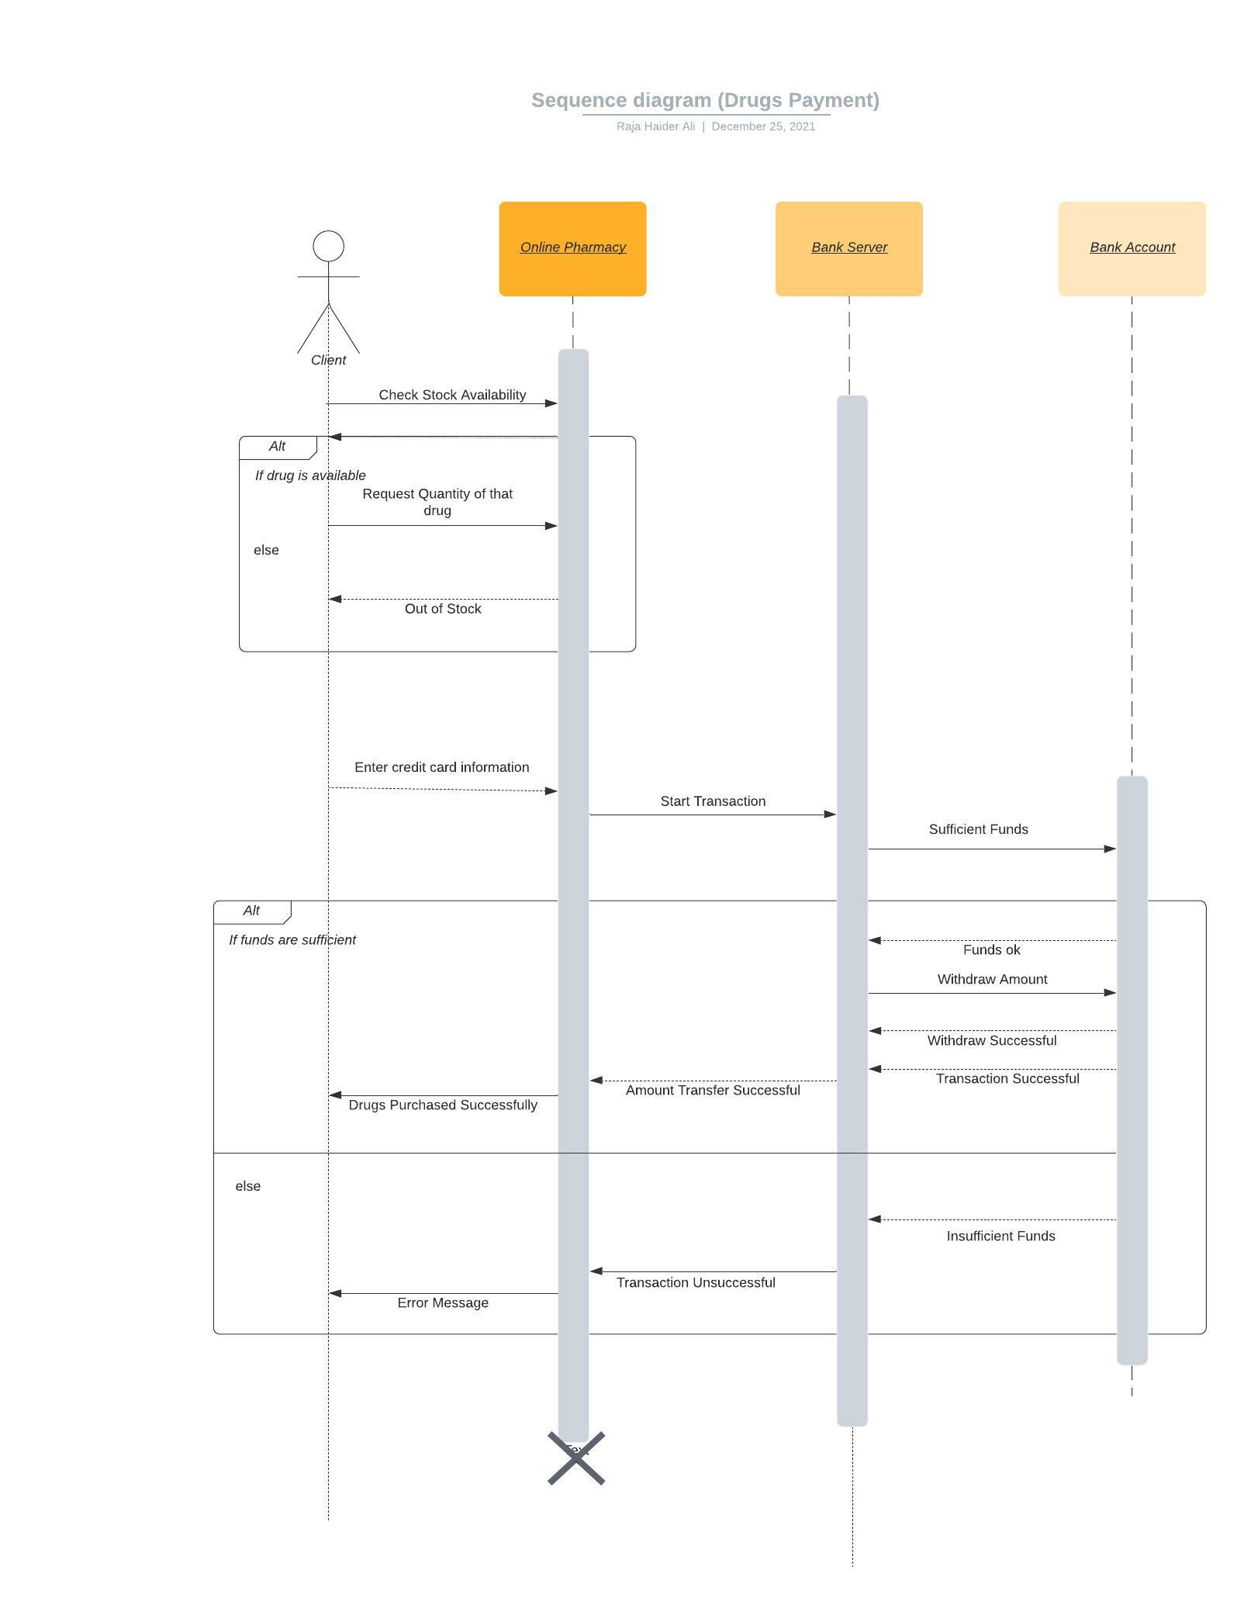

## Communication Diagram:

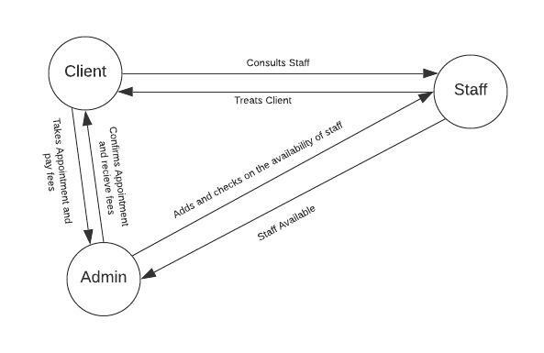

## Activity Diagram:

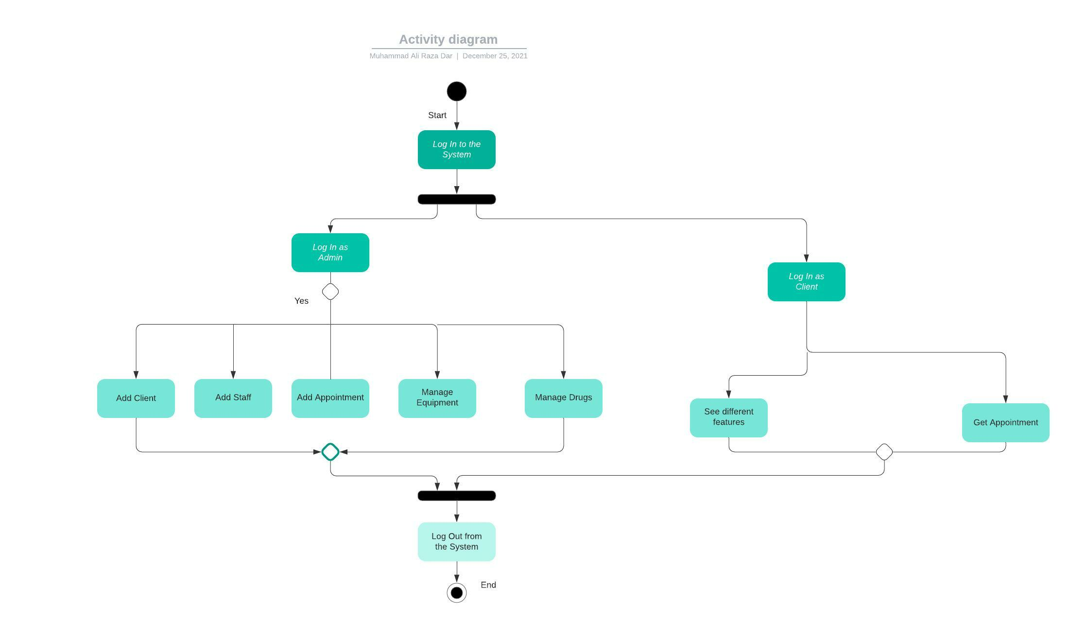

## State Machine Diagram:

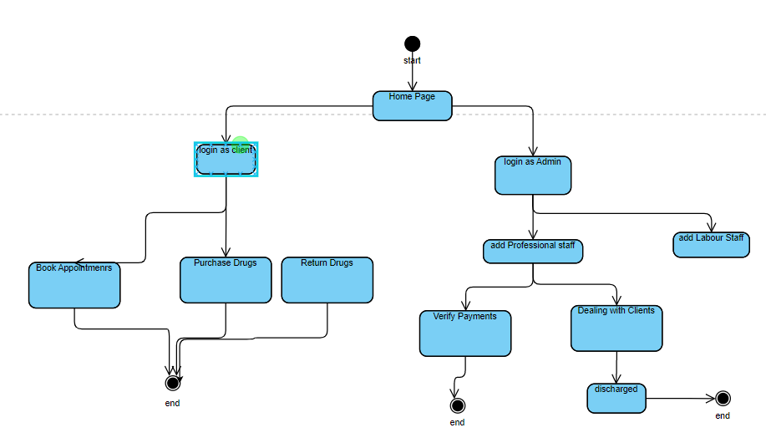

## Deployment Diagram:

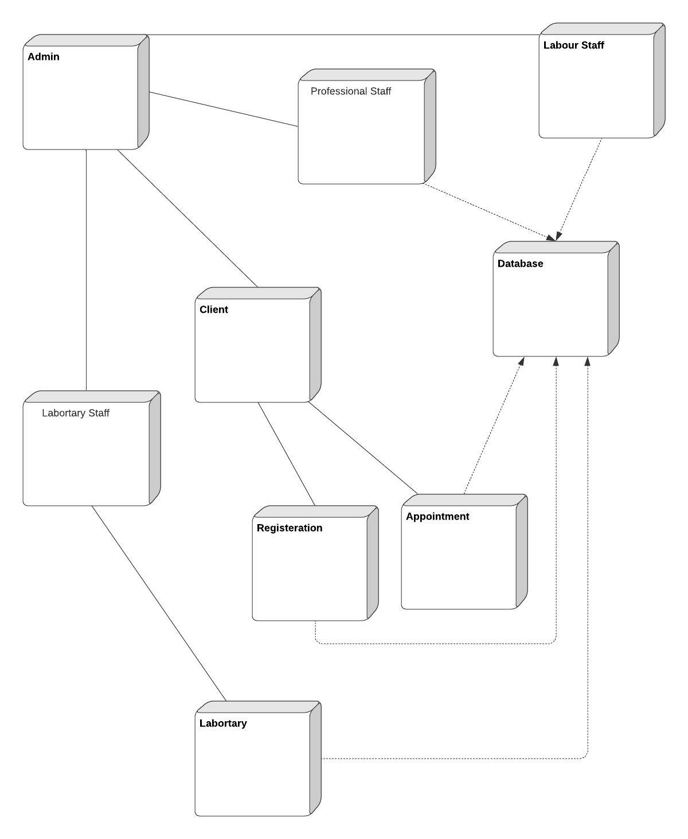

## Component Diagram:

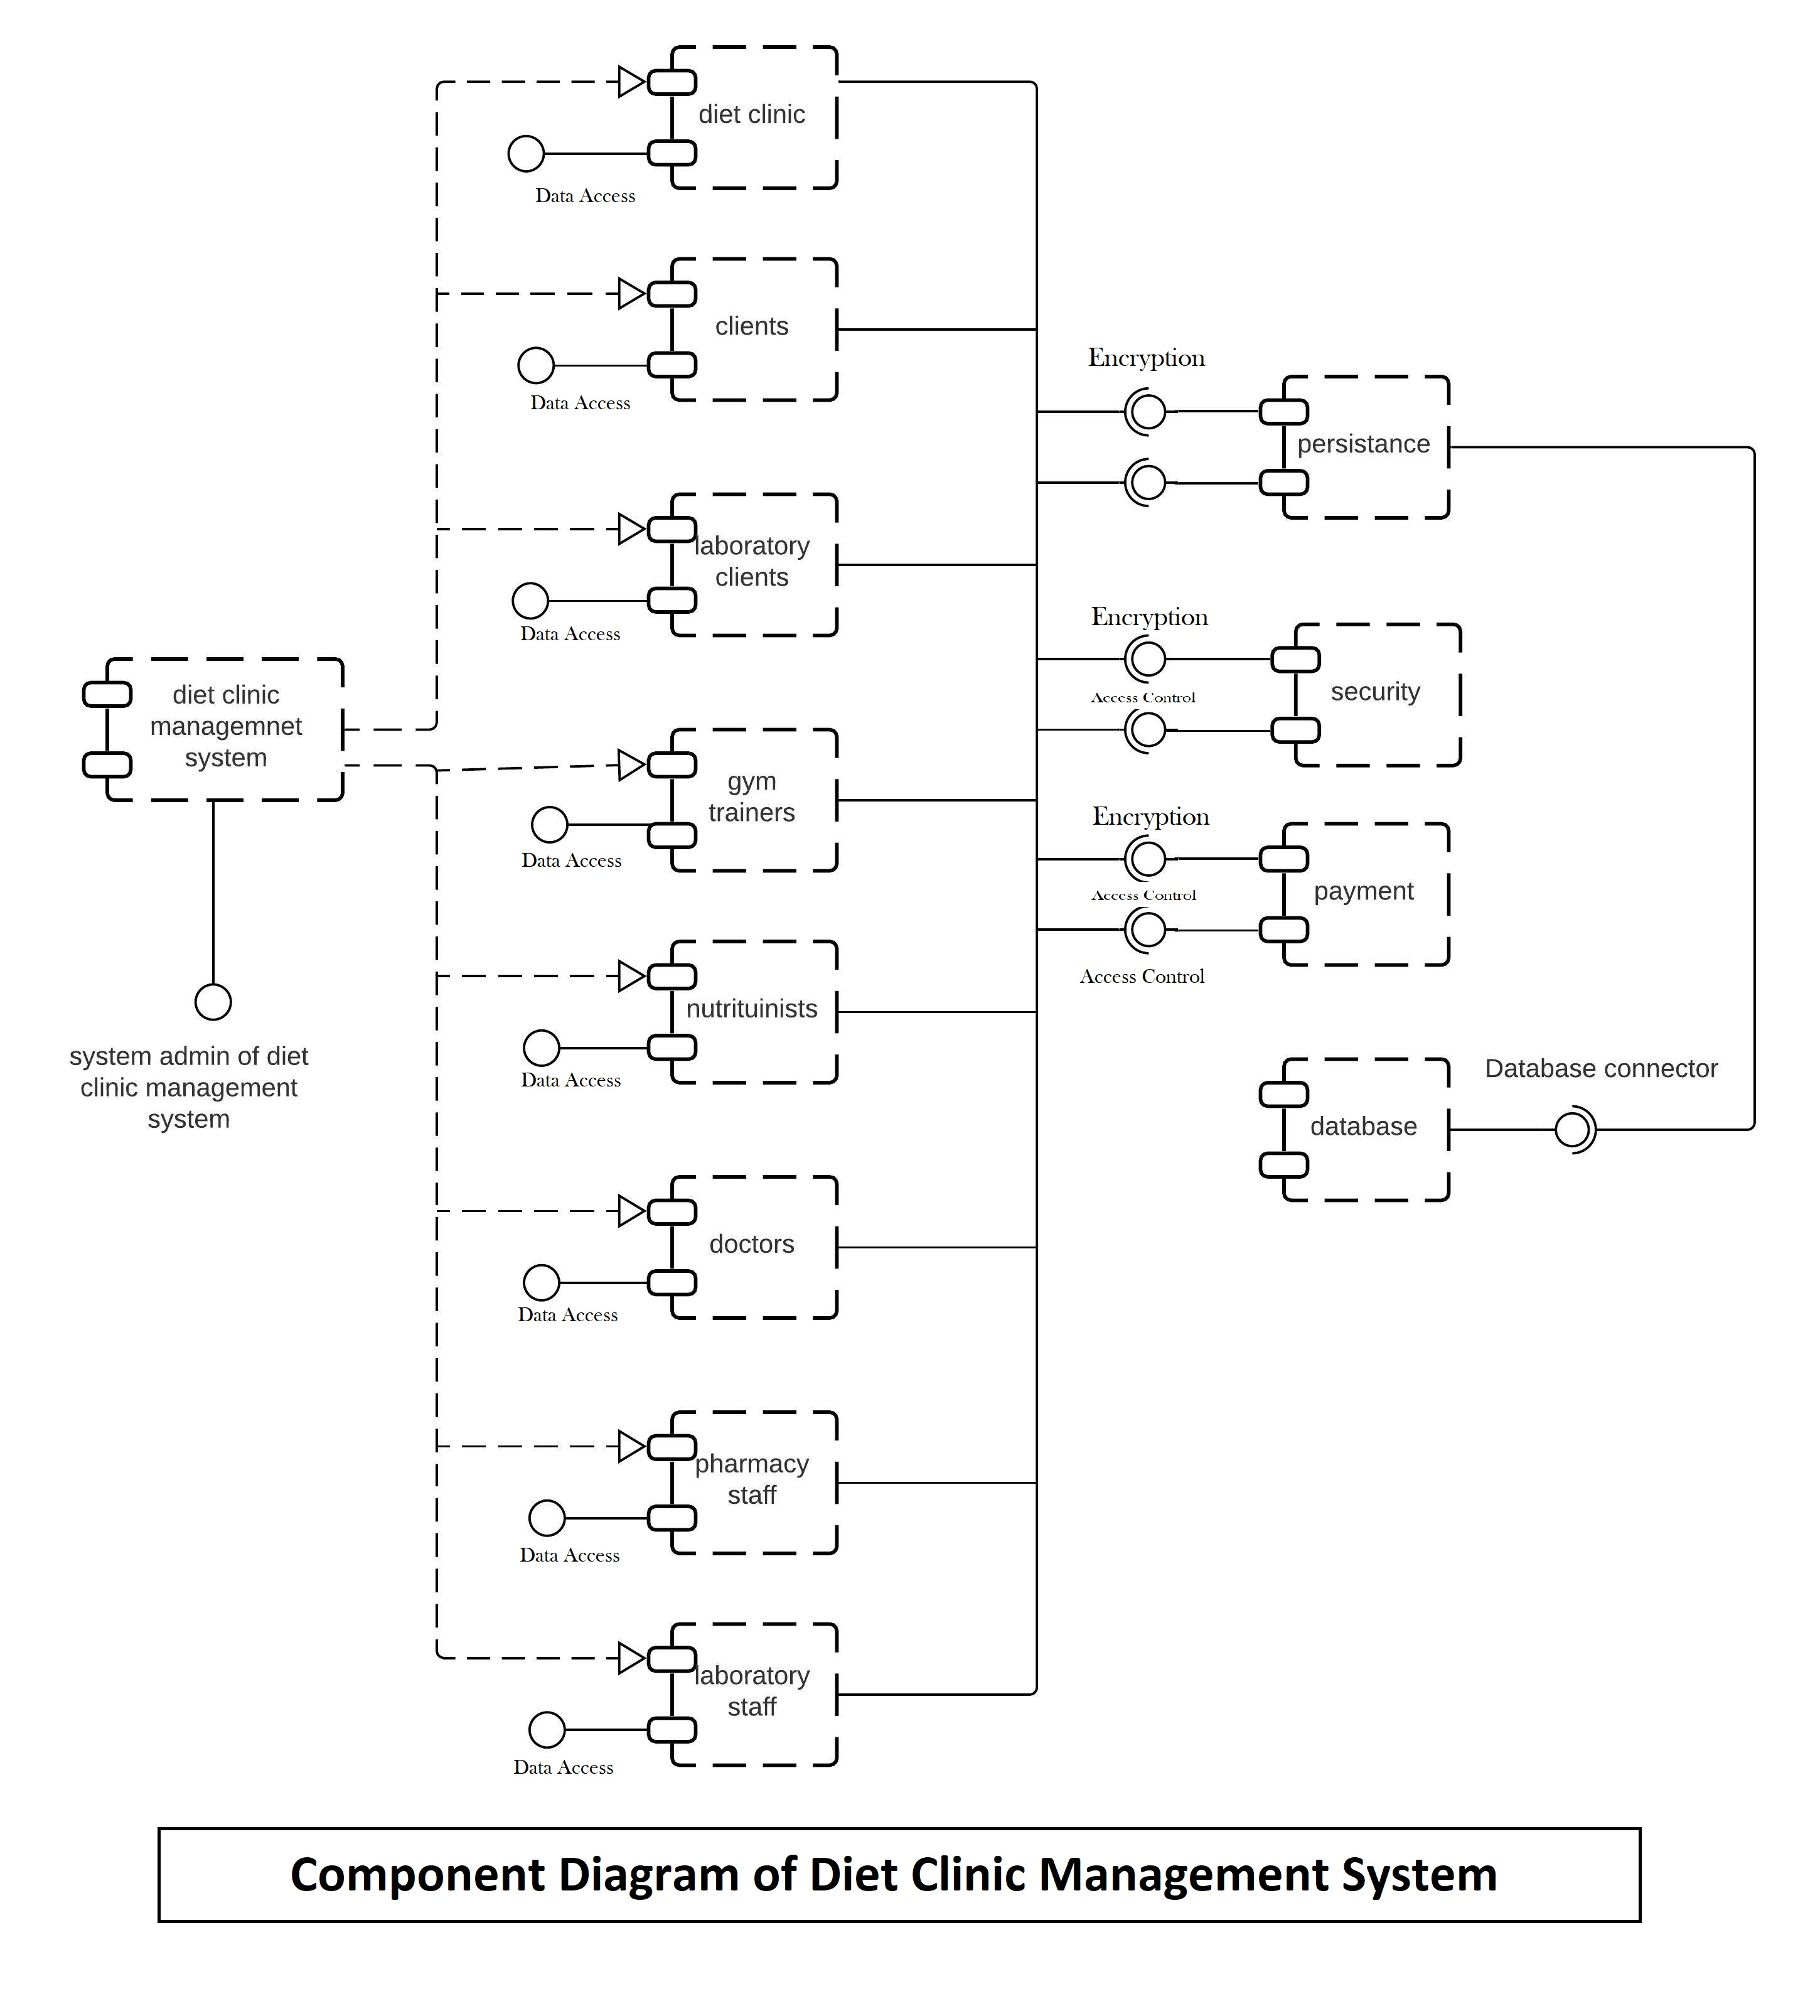

## Package Diagram:

